Exercise 18-5

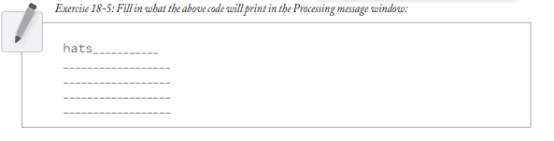

* hats
* apples
* cars
* phones
* %
* elephants
* dog